Open Letter
Eurasian network of People who use drugs

TO THE DECISION MAKERS of the state and public organisations as well as of the organisations of other forms of ownership declaring their goals as provision of help to the people who use drugs.

TO THE DONORS investing in Eastern Europe and Central Asia (EECA) for the purpose of provision of help to the people who use drugs.

TO THE INTERNATIONAL EXPERTS providing technical assistance to the governmental services and non-governmental organizations in the EECA region developing programs for people who use drugs.

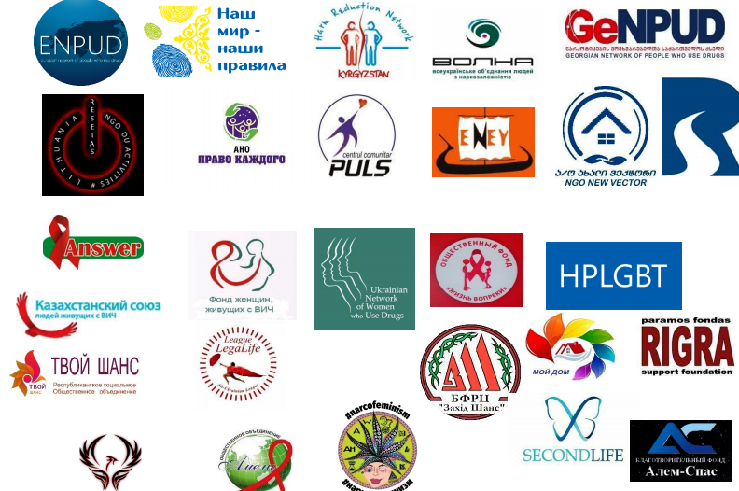

We, people who use drugs and live in the EECA region, appeal to you in confidence that our voice must be heard.

Below we list our proposals about how and where to invest the resources in the COVID-19 situation:
- creation of normal living conditions for people dependent on psychoactive substances and maintaining the access to life-saving medicines and services;
- avoidance of hunger and poverty, prevention of loss of housing and abilities to feed and educate our children.
Every proposal is justified scientifically and economically, they are aimed at the observance of human rights and reflect the recommendations of the UN agencies, non-governmental organizations and thematic experts on the international, regional and national levels.
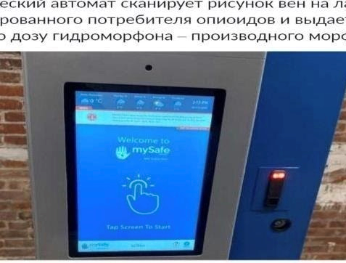
The ability to accept help is part of the service organization process. In the situation when the authorities controlling the quarantine and self-isolation regime in their respective countries have gained access to the medical information and the citizens' travel plans, make sure that your offer of assistance accounts for the need to ensure that the people are protected from the additional problems originating from the medical, social and/or law enforcement services.

[ILLUSTRATION: Biometric automatic dispenser scans the image of the veins on the palm of the registered user of opioids and dispenses a safe dose of morphine derivative hydromorphone]

Here’s how you can help us preserve health and lives in the times of a pandemic:
- Accept new participants in methadone and buprenorphine programmes. How can it be possible to close the doors of the substitution therapy now? “We are not accepting new applicants” is not the answer. Many of us need daily opiates intake. It so happens that during an epidemic the illegal drug market keeps working, while the assistance services for the addicted people don’t.
- Let people check out methadone medicine and buprenorphine for home administration. There is no excuse for forcing people to travel to a different city and to worry every day: will the police checkpoint let them through, will their body temperature go up, where could they find the money to pay for a taxi because public transport does not work and it could take hours to get home on foot?
- Ensure that daily OST remains available to those program participants who feel more comfortable with daily medication without checking them out for self-administration during the quarantine. For example the employees of public organizations implementing OST support projects could check out medication on their own, obtain an official pass allowing their movement around the city area to deliver methadone/buprenorphine to certain people on a daily basis.
- Ensure compliance with COVID19 preventive measures at OST sites. Think about the people who wait outside in the street or queue for the medicine: distribute the masks to the people waiting outside, install a disinfectant dispenser. You must understand: many smoke, they hold the cigarette filter in their fingers. We could first clean our hands after we come by public transport and light a cigarette after.
- Use the mobile outpatient clinics of the NGOs that have been engaged in risk reduction programs to deliver methadone/buprenorphine/ART/TB treatment medicine/groceries and essential goods to the homes of the people.

Here’s how you can help us avoid hunger and poverty, loss of housing and our abilities to feed and educate our children:
- Make sure that the people quarantined outside their homes or in other cities or abroad have access to harm reduction, OST and ART treatment, to health insurance for emergencies as well as to the basic resources.
- Support and create amnesty initiatives for the prisoners and for those who are kept in pre-trial detention centres on charges of possession, manufacture of psychoactive substances without the purpose of selling.
- Advocate for the police to stop detaining and forcibly transporting people who use psychoactive substances or those people who help us maintain the access to OST to regional departments. We are trying to set up safe paths both for us and for the people who help us; however we have to do it in the severely restricted conditions. When we move around the city now we are plainly visible to the police. They had little trouble to imprison us before, now it has become an effortless task for them.
- Assist us in obtaining permits to stay on the streets in order to reduce the risks of heavy fines for violation of the quarantine or self-isolation regimes.

We are in touch with the people who need help. We have an understanding of what immediate human needs are to be met in order to avoid more serious problems later.

- Groceries, cigarettes, essential goods.
- Medicines, masks, gloves, respirators, syringes, needles, alcohol wipes and other harm reduction supplies.
- Compensation of the travel expenses to the OST and AIDS centres, to the tuberculosis and social assistance services. Every day you need to find money to pay for a taxi which has become two to three times more expensive, since public transportation coverage is currently limited.
- Online counselling for the people experiencing unforeseen negative consequences when using psychoactive substances, including online medical and psychological counselling of tolerant specialists on general health issues.
- Substances tests. Information memos that are needed today: how to get out of a bad trip at home so that you won’t lose your sanity if the substance is of poor quality; how to protect yourself from coronavirus when you are looking for the drugs left for you by the dealer on the street, which psychoactive substances are less dangerous from the point of view of maintaining mental health in the self-isolation conditions.
- Help in organizing life in quarantine: creating spaces to watch thematic films through Telegram and other communication channels already utilised by the community, discussing options of how to use the time spent at home for the development of one’s potential

Online work of street lawyers/community for the people inside and outside of the places of forced detention. Range of assistance to be offered:
- Economic advice: individual help to everyone with unemployment or emergency benefits offered by the state in connection with the epidemic. Checking the possibilities to postpone the payment of utilities and rent without penalties. Help with preparation of the addendums to the contracts that will help avoid the accrual of high interests due to inability to pay the obligations on time.
- Legal advice on detention/arrest; pre-trial detention; prison, colony.
- Helping female survivors of violence: risks of domestic violence in quarantine settings are increasing. A possibility should exist to transport women to a safe space, to provide psychological and medical assistance.
- Help for mothers/single fathers with their children: organization of the educational process in quarantine; child care assistance.
- Services for homeless people, including distribution of prevention kits including soap, antiseptic gel, masks and gloves. Social shelters should be open round-the-clock providing access to showers, clothes, food, medical care. It is warm now, so it is possible to erect military tents in the places where people gather and to invest in organizations which already have experience in practical support of running shelters; provision of community support.

The ability to accept help is part of the service organization process. In practice this means that the proposed ways of solving problems have to be aimed at respecting the interests of the people who use drugs, have to take into account our life circumstances and the availability/unavailability of a safe way for us to accept your help.

It is impossible to create or adapt a service in the situation of COVID19 in the interests of our community without representing our real interests in the processes of priorities development, programming, organization and monitoring of the delivery of the services.

Simplify the process of reconciling the changes to the budgets; be flexible when considering the possibility of budget redistribution by our organizations and/or in the interests of our organizations as well as in the matter of allocation of funds for the direct activities due to COVID19. At the beginning of March 2020 donors provided information about budget reallocation opportunities in response to COVID19. At the same time even those minimal resources we have received into the accounts of our organizations within the framework of current projects still cannot be used for what is needed most urgently.

We represent groups and organizations of the communities of people who use drugs, who maintain daily connection with the street and prisons, and we are ready to provide our expertise, experience and knowledge of the real situation of our people in the context of COVID19.

The path shall be overcome by the person walking it.

Eurasian Network of People Who Use Drugs. 137 activists from 13 countries

Initiative Group PULS (Moldova)
ANO “Pravo Kazhdogo” [The Right of Everyone] (Russia)
Harm Reduction Network Association of Kyrgyzstan
OF “Tvoy Shans” [Your Chance] (Belarus)
NPO “Resetas” (Lithuania)
IG “Rubiconi” (Georgia)
“People Who Use Drugs for Humane Drug Policy” (Georgia)
CO CF “The All-Ukrainian Union of People Who Use Drugs VOLNA” (Ukraine)
PO “Club Eney” (Ukraine)
CO “The All-Ukrainian Union of Women Who Use Drugs VONA” (Ukraine)
HPLGBT Ukraine
CO “The All-Ukrainian Legalife League” (Ukraine)
CO CF “Zapad Shans” [West Chance] (Ukraine)
CF “Vtoraya Zhizn’” [Second Life] (Ukraine)
Forum of People, Who Use Drugs in Kazakhstan Republic
The Foundation of Women Living with HIV (Kazakhstan)
PF “Moy dom” [My home] (Kazakhstan)
PO “Ameliya” (Kazakhstan)
ALE “Kazakhstan Union of People Living with HIV”
PF “Answer” (Kazakhstan)
PF “Ruka pomoshchi” [Helping Hand] (Kazakhstan)
ALE “Doveriye” [Trust] (Kazakhstan)
PF “Shag v budusheye” [Step into the future] (Kazakstan)
NPO “Noviy Vektor” [New Vector] (Georgia)
Support foundation RIGRA (Lithuania)
Narcofeminist movement of EECA
Fenix 2009 (Georgia)
PF Charity Foundation Alem-Spas (Kazakhstan)

Here you can find a topical list of information and guidance resources which the International Drug Policy Consortium continues to update in the weeks to come as means to increase sustainability and solidarity. https://idpc.net/alerts/2020/03/covid19-important-information

