Position Paper of the Eurasian Network of People Who Use Drugs,
how opioid substitution therapy programs should be organized
from a scientific and human rights perspective
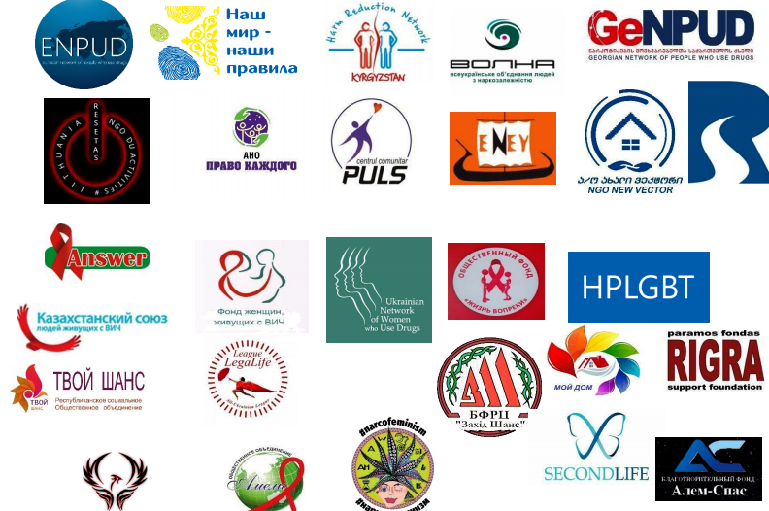

ENPUD joins the global #peersinpandemic campaign.
Today, we demand support and expansion of the provision of opioid substitution therapy (OST) in the arms.
In connection with the pandemic, 47 countries in the world have offered to hand out OST. With the lifting of the restrictive measures, some countries have already canceled the extradition. However, we know from our own experience that OST provision is an important part of ensuring the safety and health of people who use drugs during a pandemic.
#peersinpandemic
#TakeHomeOST
#ВозьмиДомойОЗТ
#ОЗТнаРукиРаботает
#Ядоказательство
Substitution maintenance therapy programs and risk reduction services should be built around and continuously adapt to the living realities and lifestyles of people who use psychoactive substances, rather than trying to break our individuality and forcibly change our lifestyles by applying inflexible conditions aimed at controlling and limiting opportunities to realize the potential of people seeking help.
The position paper of the Eurasian Network of People Who Use Drugs means that this document is fundamental for the community in advocacy on setting priorities for financing, organizing, monitoring, and evaluating OST programs in the ENPUD member countries. These countries include the region of Eastern Europe and Central Asia, as well as the countries of the Baltic region and Germany.
The ENPUD position paper draws on the principles and values of the community of people who use drugs. It complies with the Position paper of the International Network of People Who Use Drugs on extended-release OST and includes a description of how these principles and approaches should be reflected in activities.
All services and health care for people who use drugs are most effective when delivered in the context of a dynamic partnership between health care providers and people who use drugs, in an open, impartial, respectful, and honest relationships, tailored to the individual needs in contrast to the “one size fits all” approach, in which the vast majority of services and interrelations do not work.
Concerns about adherence are often rooted in stigmatizing biases of health and other service providers. In doing so, general, simplified conclusions are frequently made due to the erroneous statement that people who use drugs are unreliable and/or do not meet the requirements. The myopic focus on adherence fails because it does not take into account life experiences and the conditions in which people who use drugs live. It also does not take into account how significant psychoactive substances are in our lives for physical and social life and maintaining relationships in the community.
The WHO's Essential Medicines Program aims to ensure sustainable universal access to essential drugs through the development of an appropriate government drug strategy. It is always consistent with human rights principles such as non-discrimination and caring for the poor and vulnerable.
Since there is no single treatment that is effective for every person with opioid dependence, there must be a wide range of options available across countries. Substitution maintenance therapy is one of the most effective methods of opioid dependence treatment (WHO, UNODS, UNAIDS 2004). Opioid substitution therapy includes prescribing opioids such as methadone, buprenorphine, diamorphine (heroin), or hydromorphone to people who themselves use heroin or other opioids for a long time. Methadone and buprenorphine are on the list of essential medicines of the World Health Organization.

Core principles to guide the approach and action plan for opioid substitution maintenance therapy programs

The name of the program of substitution maintenance therapy contains two core principles, the correct implementation of which affects the effectiveness of the program:

- The substitution drug must affect a person similar to the substance that caused the addiction.

- Supportive therapy means the establishment of a therapeutic environment that promotes the expression of a person's creative skills and offer opportunities for their realization.

The approach to implement these principles in practice includes ensuring the safety and free service for the program participant, respect, as well as professionalism in the relationship between the medical staff and the clients of the program; willingness to accept feedback from clients of the program with subsequent efforts to improve the program.
The components of the approach and core values, the presence of which determines the level of effectiveness of the substitution therapy program.
the substitution therapy drug should have a similar effect as the substance that caused the addiction.
a range of drugs that allow the doctor and patient to choose the best treatment option: methadone, buprenorphine, long-acting methadone, diamorphine (heroin), or hydromorphone.
Germany, 2019: ‘Why did you suffer the whole day?! I told you, come, and we will pick up the medicine right away.’ The program includes five types of OST drugs: regular methadone, long-acting methadone, buprenorphine, hydromorphone, and medical heroin. Here is Ali's video testimony on how a doctor was helping a person to choose the most effective one out of 5 drugs. Ali is now taking morphon because methadone and buprenorphine did not suit him as substitution therapy drugs.  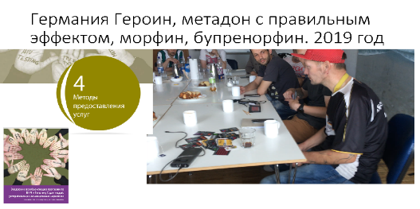 | Georgia, 2020: ‘Even though I have been taking methadone for almost 12 years, this medicine cannot substitute the drug that I took for more than 30 years before seeking help. I started with codeine in combination with noxerone, then morphine, raw opium, poppy or poppy extract, and heroin. Methadone effect lasts longer, so there is no physical pain and intolerable insomnia, as it was in situations with shortages in substances supply. However, methadone causes conditions different from heroin: instead of sleep, you turn off. Using methadone, I do not have enough energy that I used to get from natural opiates. Now I have to force myself to do things that I used to do with pleasure being on street substances. Medical heroin would be the best choice of medicine for me.’

- To use international experience and clinical practice in organizing the provision of medical and psychological/psychiatric care for people who use club drugs and new psychoactive substances.
- A pharmaceutical form of medicine: procurement specialists should also think over which pharmaceutical forms are better to procure in order to ensure service implementation: dispensing medication for self-administration. There are also opportunities for the use of innovative forms of OST drugs (for example, patches) upon the patient’s request.
- Peculiarities of the use of prolonged forms of substitution therapy:
Long-acting buprenorphine. The buprenorphine patch can be helpful for people on OST that want to make their lives more comfortable by reducing their contacts with the healthcare facility and switching to monthly treatment with their GP or pharmacist. Likewise, in countries where home use is not widely available or not available at all, these substances can withdraw many dosage restrictions, allowing people to travel without worrying about collecting and receiving regular medications. Likewise, they will reduce inconvenience in cases where frequent travel to clinics is burdensome and difficult (thus creating a barrier to health care).
However, long-acting buprenorphine can also be used as a control and enforcement tool. This fact not only undermines a person's ability to choose how and when he or she uses drugs but additionally deprives a person of the opportunity to self-regulate opiate use for the desired psychoactive drug effects.
Naltrexone implants are used as withdrawal therapy for patients with opioid, alcohol, and, to a lesser extent, amphetamine dependence. As a part of a fundamentalist moralistic approach to drug use based on abstinence, Naltrexone has been heavily promoted and marketed to the criminal justice system despite its high risk of overdose (with a death rate four times higher than methadone and substantially higher than buprenorphine). It was this approach that led to the outburst of deaths of an overdose in Australia in the late 1990s. A lot of opiate addicts are reluctant to use Naltrexone or refuse to take it. Many others start taking it but do not continue treatment. Long-term studies on Naltrexone use have not been conducted yet.
The quality of medicine is more important than the criterion “lowest price” per pill. By focusing on the quality of the medicine, the organizers of the service maintain the attractiveness of the program to people. They also save resources for the management of complications due to the side effects of poor-quality medicine. The low quality of the drugs for program patients means a drug that does not work well enough to make them feel normal. As a result, people have to look for options that will help them to achieve the effect their bodies need in the risky context of the repressive drug policy and illegal drug scene. Having saved one dollar on the quality of the pill, further financial losses will significantly exceed the savings in the long term perspective. It will happen due to the need to treat the harmful side effects of low-quality psychoactive substances and risky living conditions within the illegal drug scene.
- constant access to medication – availability of a supply of medicines sufficient to eliminate the risks of interrupting the treatment or excluding clients from the program due to the lack of medicine.
- ensuring conditions for constant access to medication in case of illness.
- provision of conditions for obtaining a drug for self-administration (for example, take away doses):

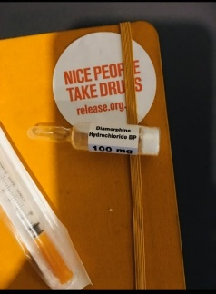  Participants in evidence-based OST programs can receive methadone, buprenorphine, morphine, medical heroin, including take away doses for self-administration. Moreover, physicians, together with anthropologists, conduct studies to demonstrate to the professional community the benefits of this approach. | Kazakhstan 2020: During the COVID-19 epidemic, the movement of people between cities and towns was restricted, resulting in disruptions in access to methadone treatment. The problem could be solved by the provision of take away doses for self-administration for seven days. However, the medical personnel was looking for any other option: prescription of Tramadol or referral for short-term detox. The proposed options aimed at the convenience of the clinic staff and officials: we are either under sleeping pills in the hospital or out of sight somewhere out there, using Tramadol. Strangely, it is difficult for you to understand – it is impossible to change the physiology and lifestyle in one day. Such decisions should be made in different circumstances, not in a stressful situation or forcibly because government officials are afraid to take responsibility to act in the best interests of patients.

- the fewer barriers to access, the better. For example, OST medicines should be available at needle and syringe exchange points.
Supportive therapy means establishing a therapeutic environment that contributes to the expression of a person's creative skills and opportunities to exercise them.

- eligibility criteria for participation in the program must be ethical and scientifically justified. Ethical means that access to a vital medicine for a person cannot be used for extortion, manipulation, and blackmail.
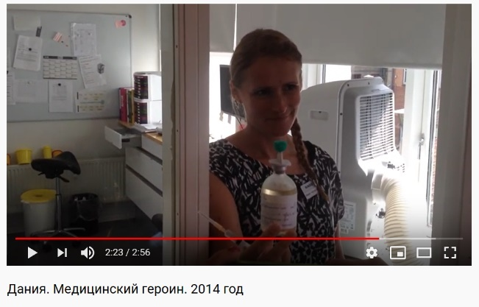
Denmark, 2014. The doctor greets us with a smile and immediately says: 'Please, a little quieter. A man took medicine and is resting in the next room'. Looking into the doctor's eyes, we were convinced that she truly understood that the specifics of the environment were as important as the quality of the medicine. Therefore, the premises of the OST clinic are light and warm. There is a place to rest after an injection of heroin. There is an opportunity to get methadone at night because the doctors understand that the effects of heroin will not be enough until the morning. 'We create an environment where people can show their best qualities, such as trust and friendliness.'
Actions to be taken for substitution maintenance therapy programs to bring the effect which is potentially present in this approach:
- decriminalization of the use and possession of psychoactive substances for one’s own needs allows a person to seek medical help without consequences such a restriction of rights and the risk of losing freedom.
- practicing humane treatment of people who use psychoactive substances: communities of drug therapists/psychiatrists and law enforcement officials have changed the meaning of the discussion and practical activities from stigma to acceptance, both in the words you use and in the actions.
- helping to establish and maintain social centers managed by the community or with the community that influences decisions about the centers. The task of the social center is to provide shelter, food, and the solution of urgent social problems for people who use psychoactive substances and are in difficult life situations.
- it is useful to locate the OST offices close to the places of residence of people in need of the service. Office hours should include both the opportunity to get early in the morning and later in the afternoon, until the evening. When choosing a dosage and in other cases, it is necessary to divide the daily dosage into several doses.
- refusing to exclude a person from the medical program because of the manifestation of the disorder. The presence of psychoactive substances that were not prescribed by the doctor in the urine analysis is an occasion to discuss with the patient the adjustment of treatment, with keeping the person within the legal framework and with further access to OST treatment.
- using the latest scientific data for practical application. For example, cannabis can stabilize the dosage of opiates while also reducing anxiety as well as restoring sleep and appetite. Instead of demanding clean urine by any means, look at what substances a person uses in combination with OST. A specialist can discuss with the person why he/she uses them and what effect is achieved, as well as how this effect helps the person to live. You can think together about the risks and consequences of interactions among the substances. It is also necessary to speak about risk reduction.
- creating professional mental health services: to help people with mental health problems related to substance abuse is an essential part of a substitution-maintenance therapy program. The reason for using more of the substance may also be the inability to cope with stress in other ways. A consequence of the lack of quality mental health and psychiatric care is an increase in overdose mortality during the quarantine period.
- to learn how to form adherence to taking medicine in the right dosages in the case of inpatient care at home or quarantine. Here, as with other diseases, the help of peers who already adhere to treatment is invaluable.
- the indicators of program evaluation should be as follows: first of all, stress reduction; increasing psychological stability for going through life events; experience with self-medication, and level of adherence to taking medication at the prescribed dosage.
- conducting the community monitoring of the value of investments allocated to the narcological services and assessing the quality of the organization and the effectiveness of these services.
When organizing services for people who use drugs, trust our life experience and unique knowledge, then you will create a program with conditions that can reveal the life potential of each of us.
‘We have been trying to change people for already 30 years, and nothing worked. And only when we created the program conditions that show the value of life and correspond to the lifestyle of the person who uses drugs, we have made it,’- an addictionologist of the Substitution-maintenance therapy clinic which provides such drugs as methadone, buprenorphine, and heroin (Denmark, 2014).
The ENPUD position paper on OST aims to draw the attention of decision-makers and various stakeholders to the measures which should be performed by the government services and relevant public organizations of all forms of ownership for the OST programs to meet quality standards.
The ENPUD position paper on OST provides the basic framework for the community in setting priorities for financing, monitoring, and evaluating OST programs in the EECA region, including relevant activities conducted by the communities of people who use drugs.
Eurasian Network of People Who Use Drugs: 140 activists from 13 countries of the world self-organization of people who use drugs in the region of Eastern Europe and Central Asia.
Initiative Group "PULS", Moldova
ANO "Right of Everyone", Russia
Association “Harm Reduction Network in Kyrgyzstan”
PF "Your chance", Belarus
NGO "Resetas", Lithuania IG
"Rubiconi", Georgia
“Fenix ​​2009”, Georgia
"People Who Use Drugs for Humane Drug Policy", Georgia
ChO "CF" All-Ukrainian association of people with drug addiction "VOLNA", Ukraine
NGO "Club "Eney", Ukraine
Ukraine HPLGBT, Ukraine
ChO "CF "West Chance", Ukraine
CF "Second Life", Ukraine
Forum of People Who Use Drugs of the Republic of Kazakhstan
Fund of Women Living with HIV, Kazakhstan
PF "My House", Kazakhstan
PO "Amelia", Kazakhstan
OLE "Kazakhstan Union of People Living with HIV"
NGO "Life in spite of", Kazakhstan
PF "Helping Hand", Kazakhstan
OLE "Trust", Kazakhstan
PF "Step into the Future", Kazakhstan.
NGO "New Vector", Georgia
“RIGRA” Support Fund, Lithuania
EECA NarkoFeminists Movement
Fenix ​​2009, Georgia

Contact person – Program Coordinator
Eurasian Network of People Who use drugs
Ola Belyaeva
+38073-440-53-03
contact.enpud@gmail.com

Eurasian Network of People Who Use Drugs ENPUD includes 138 active and supportive ENPUD members from 15 countries that are experts in the human rights protection and reinstating of people who use psychoactive substances in their rights; development, planning, implementation, as well as monitoring of programs to increase the benefits and reduce the risks of using psychoactive substances; prevention, care and support programs on HIV, hepatitis, and tuberculosis. We have to become experts in clinical medicine, public health, and drug policy. Our expertise or understanding of the situation in all areas mentioned above is based on the practical experience of both the use of psychoactive substances and receiving services that include services in substitution therapy programs, in the context of both progressive and repressive drug policies.
Extended-Release Opioid Agonist Products A Community Position Statement, INPUD, 2019
Extended-Release Opioid Agonist Products A Community Position Statement, INPUD, 2019
Substitution maintenance therapy in the management of opioid dependence and HIV/AIDS prevention: position paper / World Health Organization, United Nations Office on Drugs and Crime, UNAIDS, 2004.
World Health Organization. Model List of Essential Medicines 21st List 2019. Page 54, point 24.5 Medicines for disorders due to psychoactive substance use.
Czech. 2019. Pavel Bem, Viktor Mravchik, David Peshek: Substitution Therapy: Principles in Practice. Video The Way of Peter filmed by Drugreporter and video description in Russian.
Testimony of Ali, a substitution therapy client in Berlin, Germany, on the drug selection process: methadone, buprenorphine, so far he settled on morphon. (2017)
Neptune, Novel psychoactive treatment UK network http://neptune-clinical-guidance.co.uk/e-learning/
Video ‘Medical heroin in Denmark: pills or injection fluid’ (2014).
In Europe, the first long-acting opiates (weekly and monthly buprenorphine injections) were licensed for use in November 2018. In the United States, a six-month implantable drug and a monthly injection drug have been approved and are currently being marketed. Extended-Release Opioid Agonist Products. A Community Position Statement, INPUD, 2019.
Extended-Release Opioid Agonist Products A Community Position Statement, INPUD, 2019
Extended-Release Opioid Agonist Products A Community Position Statement, INPUD, 2019.
Methadone diversion as a protective strategy: the harm reduction potential of “generous constraint”, M. Harris, T. Rhodes; International Journal of Drug Policy accepted on 7th of October, 2012.
#ЛУНаКарантине Issue 2; ENPUD, 03.04.2020; Documenting events in countries during quarantine.
Germany. An example of the work of shelter for the homeless. Post by Aidana Fedosik, an internship at ENPUD, 2019.
Kyrgyzstan. “Ranar” Social Center that is run by the community. Post by Olya Belyaeva, EHRA, 2017.
Czech. SANANIM Center – risk reduction services, assistance in social adaptation. EHRA /ENPUD, internship, 2018.
2018. The Benefits and Effects of Using Marijuana as a Pain Agent to Treat Opioid Addiction Griffith C and La France B* Howard University Hospital, Washington DC, USA..

